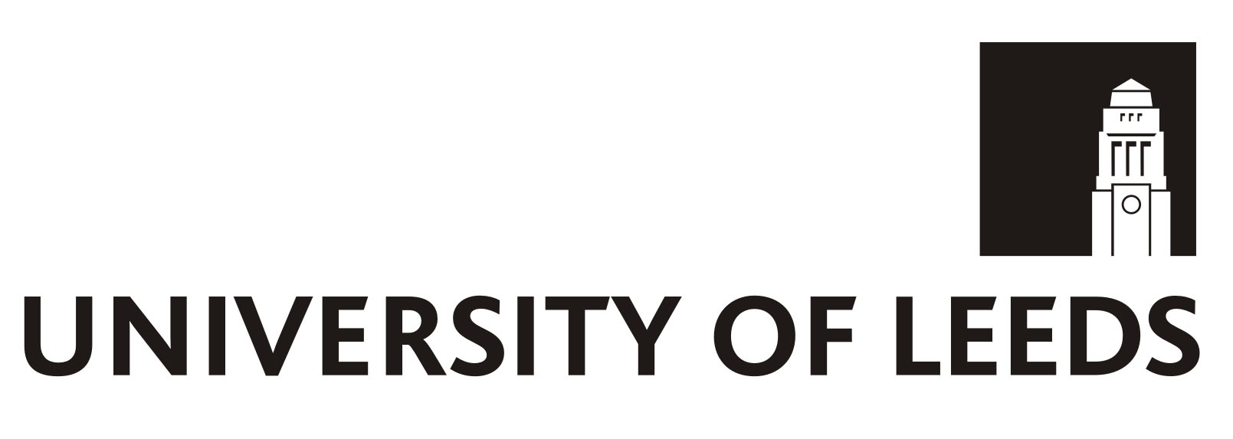
The University of Leeds

Withdrawal from Active membership form – Only to be used once outside of the Opt out period

Members Name…………………………………… Department ……………………………………….

Personnel Number………………………………… NI Number………………………………………..

Member’s Declaration

- I wish to withdraw from membership of the University of Leeds Defined Contribution Plan.

- I understand the benefits which I am giving up.

- I understand that if I leave the Scheme, I will lose the right to the employer contributions which are made by the University.

- My contributions to the Scheme will cease with effect from the first of the month following receipt by the Pensions Department.

- It is my responsibility to make, for my dependants and myself, whatever pension provision I feel is necessary. My dependants (spouse, children etc.) and I will not be entitled to any benefits under the Scheme. In particular, no benefits will accrue as a result of my death in service or my having to cease work due to ill health.

- Should I apply to re-enter the scheme, acceptance of my application will be subject to any conditions which the University deems at the time to be appropriate.

- I understand that by leaving the Scheme I may lose the right to join the University of Leeds Pension and Assurance Scheme, if I choose to do so in the future, within the given timescale.

- I understand that if I leave the Scheme, I may have a lower income when I retire

- I have been in the Scheme for over 1 month and wish to cease membership and understand that I am not entitled to a refund of contributions.

Reason for Opt Out …………………………………………….

Signature……………………………………………. Date ……………………………………………….

What you need to know;
- The University cannot ask you or force you to opt out
- If you are asked or forced to opt out, you can tell the Pensions Regulator www.tpr.gov.uk
- If you change your mind, you may be able to opt back in – you will need to write to the University if you wish to do this
- If you stay opted out, the University will normally put you back into pension saving in around three years
- If you change your job, your new employer will normally put you back into pension saving straight away
- If you have another job, your other employer might also put you into pension saving, now or in the future. This form only allows you to opt out of pension saving with the University. A separate form must be filled out and given to any other employer you may work for, if you wish to opt out of that employer’s pension saving as well.

