People & Culture

Applicant Guidelines
For Applying for Academic Promotion via Stonefish

Contents
1. Introduction/purpose 1
2. Accessing Stonefish 1
3. The on-line application form 3
4. Further information 4

Introduction/purpose
Our on-line promotion application system (Stonefish) for Academic members of staff was launched in September 2022. The purpose of this document is to provide clear guidance to any Academic member of staff applying for promotion through Stonefish.

These guidelines have been developed following engagement with and input from key stakeholders and will be regularly reviewed.

Accessing Stonefish
Access the on-line promotion system (Stonefish) on the Careers site.
Click on the tab in the middle headed “Staff login” (as per screen-shot one below). This will automatically log you in to the system via ‘Single Sign On’ (so you don’t need to enter any other log-in details, providing you are already logged into Office365).

Screen-shot one

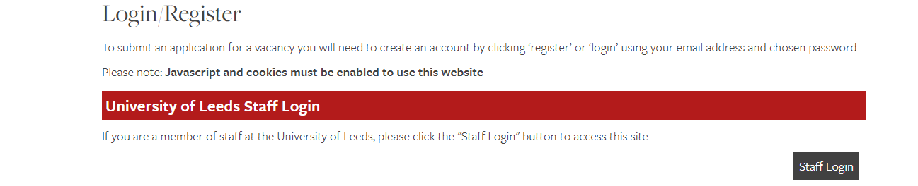

Once logged in you’ll see a tab for Academic promotions. Choose New Promotion Application (see screen-shot two)

Screen-shot two

Select Academic Promotion Application. You will then be asked to select from the drop down options menu which grade and route you are applying for. See screen-shot three below.

Once you click Continue this will take you to the application form which is pre-populated with the correct criteria for your chosen grade/route.

Screen-shot three

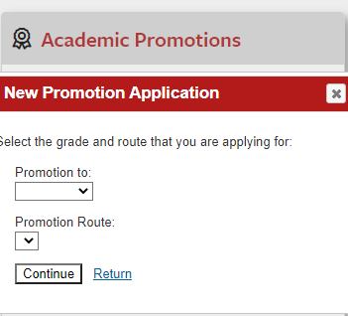

The on-line application form
You will be guided in the information you are being asked to provide and there are help buttons (?) throughout.

The application is split into the following tabs for you to complete:

The first tab is for applicant details. Please ensure you identify your Faculty and School (or equivalent e.g. Institute) from the drop-down options, as the system will forward your application to your Head of School (or equivalent) for verification. If you have any queries on this, (e.g. if you have a dual role across more than one Faculty), please contact the HR Promotions Team or your Faculty HR Manager.

You will also be prompted on this tab to attach your academic CV (not mandatory for grade 7 applications). Further guidance and template academic CV can be found on the HR Promotions website.

The second tab is for you to complete your promotion case. You will be directed to provide information and evidence relevant to the grade/route you are applying for.

You are also asked to provide details of any personal circumstances you feel have impacted on your work and that you would like the panel to take into consideration.

For applications to grade 10, please also complete a third tab with details of your three referees.

Saving your application:
The system will auto-save your application, but there is an option to manually save too. There is also an option to save into a PDF. This is helpful if you wish to share a draft for advice and guidance before you submit, e.g. to share with such as your Head of School, SRDS reviewer or mentor. To save as PDF click on Print/Download Request (which you’ll see at the top left of the page).

Submitting your application and next steps:

Once completed, click on Submit. Your application will be sent to your Head of School (or equivalent) for verifying. If your verifier has any queries or concerns, they will discuss with you. Your verifier may also provide feedback/suggested amendments (e.g. if they feel your application would benefit from further information / context around the level of responsibility, autonomy and complexity of the role in relation to addressing the criteria). If this is the case, you will have the opportunity to make any amendments to your application and re-submit.

Your application, once verified, will automatically then be sent to the HR promotions team who will arrange to set up your promotion panel. Stonefish will keep you updated, letting you know when your application has been verified and with HR.

Further information
The HR website has full information on the promotions process and all related documents. This includes for example further information on things to consider before you apply; the promotions criteria, guidance and benchmarks and, as above, Academic CV guidance and template.

Please contact the HR Promotions Team or your local, Faculty HR Manager if you have any queries.

Version/Amendment History: 002
Guidance Owner: Specialist Support – Human Resources Promotions Team
Guidance Author: Karen Garner – HR Strategic Programmes
Effective Date: 11/2022

