

MCard

The University of Leeds is a member of the West Yorkshire Travel Plan Network. Staff are entitled to a 12% discount on a Corporate Annual MCard which allows them to travel on buses and trains throughout West Yorkshire. Employees can join the scheme any time of year and will be provided with a full years travel. Payment is made via 10 monthly salary deductions.

Annual MCard Costs
12% DISCOUNT PRICES*
Bus Only Zone (1-5) | £792.00
Bus & Train Zone 1-3 | £1037.52
Bus & Train Zone 1-4 | £1219.24
Bus & Train Zone 1-5 | £1463.26
Bus & Train Zone 2-5 | £1022.03

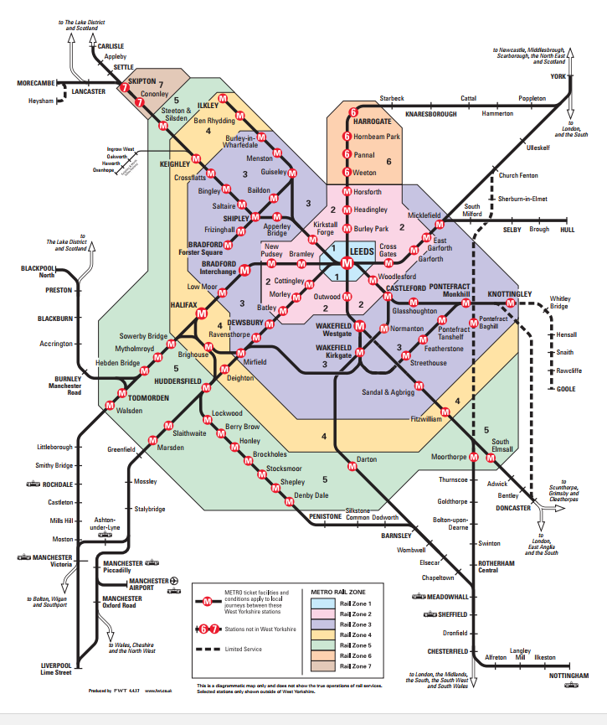

*Prices are subject to any future increases as dictated by Metro

As a first step, you will need to order your Corporate Annual MCard on the MCard website www.m-card.co.uk Please also complete the attached deduction application and return a hard copy to the Staff Benefits Team, 11.11 E.C. Stoner Building.
Please retain a copy of the Terms and Conditions.

Annual Corporate MCard Terms and Conditions

- The purpose of this Scheme is to provide discounted payment terms for staff. The University is not involved, nor liable, for the delivery of Metro services. Staff have a separate contract with Metro for delivery of their services. Metro’s conditions relating to the use of their MCard are available at https://m-card.co.uk/terms-of-use/annual-mcard-terms-conditions/

- A Bus-Only MCard is valid on virtually all the services of all bus operators within West Yorkshire.

- A zonal MCard is valid on all buses plus rail zones of your choice.

- The MCard is for unlimited use at any time of the day, for the duration of the card.

- MCards are not accepted on special bus services e.g. Football

- Zones 6 and 7 MCards are in North Yorkshire and Metro cannot cover these areas.

- Price increases come into effect every 2nd January. Corporate MCards are not affected until 1st February.

- These Conditions are subject to any change required by Metro.

- 10 monthly deductions are made direct from your salary beginning in the month your card starts.

- No deductions are made in the final two months.

- If your card is lost/stolen/damaged, you can order a replacement card by logging into your account at www.m-card.co.uk . There is a £5 charge.

- It is possible to change the ticket zone you have. A new MCard will be ordered and your deductions will be amended accordingly. Contact the Staff Benefits Team (ext. 33966).

- If you are leaving the University, please contact the Staff Benefits team to advise them of your intentions. You can either return your MCard to the Staff Benefits Team on, or before, your last working day at the University or you can retain your MCard by paying the outstanding balance due. The outstanding balance will be deducted from your final salary.

- If you are going on maternity leave, please contact the Staff Benefits team to advise them of your intentions. You can either return your MCard to the Staff Benefits Team on, or before, your last working day at the University or you can retain your MCard by paying the outstanding balance due. (Your monthly deductions will continue as normal or the outstanding balance will be deducted from your final salary, depending on when your MCard expires).

- If you decide to opt out of the Scheme, please contact the Staff Benefits team to advise them of your intentions. You need to return your MCard to the Staff Benefits Team and your deductions will cease.

- If you return your card at the start /in the middle of a month, you will be required to pay for the whole of that month. Consider returning the card by the last day of the previous month.

- No refunds will be given on any returned cards. Employees are given a 12% discount for taking out an annual card. If you return the card, you are deemed not to be entitled to this discount and Metro calculate your usage based on monthly and weekly MCard prices. The University is given a refund based on this.

- Please note, the Staff Benefits Team will not issue reminders to you at renewal time

GUIDE TO THE METROCARD RAIL ZONES

ZONE 1 | ZONE 2 | ZONE 3 | ZONE 4 | ZONE 5
Leeds | Batley  Bramley  Burley Park  Cottingley  Cross Gates  East Garforth  Garforth  Headingley  Horsforth  Kirkstall Forge  Morley  New Pudsey  Outwood  Woodlesford | Apperley Bridge  Baildon  Bingley  Bradford - Forster Square  Bradford - Interchange  Burley in Wharfedale  Castleford  Crossflatts  Dewsbury  Featherstone  Frizinghall  Glasshoughton  Guiseley  Knottingley  Low Moor  Menston  Micklefield  Mirfield  Monkhill  Normanton  Pontefract - Baghill  Pontefract - Monkhill  Pontefract - Tanshelf  Ravensthorpe  Saltaire  Sandal and Agbrigg  Shipley  Streethouse  Wakefield - Kirkgate  Wakefield - Westgate | Ben Rhydding  Brighouse  Deighton  Fitzwilliam  Halifax  Ilkley  Keighley | Berry Brow  Brockholes  Darton  Denby Dale  Hebden Bridge  Honley  Huddersfield  Lockwood  Marsden  Moorthorpe  Mytholmroyd  Shepley  Slaithwaite  South Elmsall  Sowerby Bridge  Steeton and Silsden  Stocksmoor  Todmorden  Walsden

Please note: All cards include bus travel throughout West Yorkshire.

THE UNIVERSITY OF LEEDS MCARD DEDUCTION APPLICATION

TITLE _____________________
FIRST NAME _______________________________________________________
SURNAME _________________________________________________________
PAYROLL NUMBER ______________________________
DEPARTMENT _______________________________________________________________
WORK EMAIL/PHONE _________________________________________________________
NEW OR RENEWAL? ______________________________

I wish to purchase the following MCard:

ANNUAL MCARD | TOTAL COST | MONTHLY DEDUCTION  (first 9 months) | MONTHLY DEDUCTION  (final month) | TICK
BUS ONLY | £792.00 | £79.20 | 79.20
RAILCARD-ZONES 1-3 | £1037.52 | £103.75 | 103.77
RAILCARD-ZONES 1-4 | £1219.24 | £121.92 | 121.96
RAILCARD-ZONES 1-5 | £1463.26 | £146.32 | 146.38
RAILCARD ZONES 2-5 | £1022.03 | £102.20 | 102.23

I, the undersigned, agree to purchase this card from the University. I certify that the details given herein are correct.
I confirm that I have read, understood and agree to all the Terms and Conditions laid out in this document.

Upon signing this agreement deductions at the appropriate rate will commence from your salary automatically effective from the starting month of your MCard.

Signed.......................................................... Date......................................................................

