Employee Guide
Corporate Annual MCard online process

Release: Version 1
Date: 04/04/2018
Authors: EH

Contents
How do I order a Corporate Annual MCard on the website? 3
How do I register for an account? 4
Applying for a new Corporate Annual MCard 5
Organisational Details 6
Application Details 7
Photograph 8
Terms and Conditions 8
Review of Order 9

How do I order a Corporate Annual MCard on the website?

- Go to the MCard website  (www.M-Card.co.uk).  - Click on the sign in/ register button at the top of the screen  - Register for a new account. | 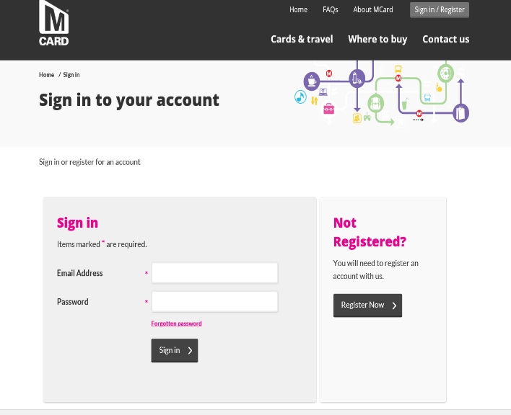  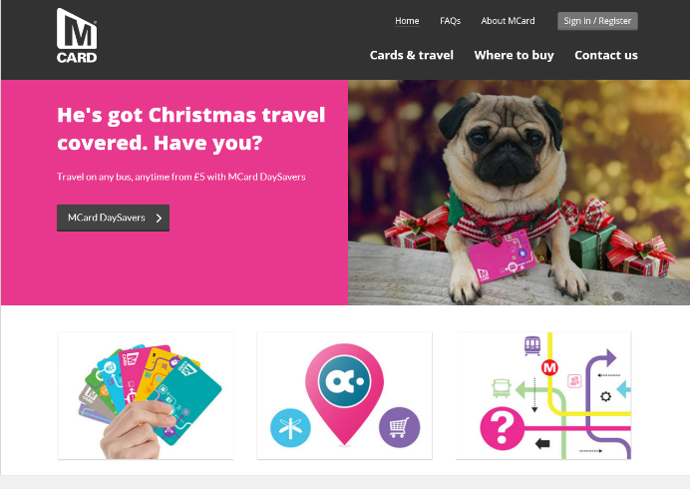

How do I register for an account?

- Registration form
You must input your
- First Name,
- Surname,
- Postcode (use the post code look up to find their address),

- Date of birth,
- Email address and confirm email address
- Password (twice for confirmation).
- Read and accept the Privacy Statement

Then click Register button. –
NOTE –
- The password should be eight characters or more, and should include at least one number and one upper case (capital) letter.
- First Name, Surname and DOB cannot be changed online once entered. If these fields require changing the Employee will need to go to a Travel Centre with proof of the change

Applying for a new Corporate Annual MCard

What the Icons Mean

- Apply for a Travel Card – this will show you what type of cards you are able to apply for (age related) This is where you will apply for your Corporate Card
Manage Travel Cards – this is what cards you have (live cards) and if you are able to replace or renew
Update Account Details – you can amend your details here i.e. change of address
Register a dependant – this is if you have a family member who is eligible for a pass i.e. a parent who is entitled to a senior pass, or a child who requires a school bus pass, you can order one for them on their behalf

- Cards For Me this shows all the cards you are eligible to apply for
- Click on Apply for Corporate Annual

Organisational Details

- You must input your
- Staff ID/Payroll Number,
- Organisation reference number – UNI1

- Organisation Name – University of Leeds
- Select the right ticket type (use the zone map link to check you have selected the right ticket type)

- Click Next

NOTE
- All fields are mandatory and incorrect information will lead to a delay in approving your application.

- If you get an error message, then check the right Organisational reference number and Name has been entered or speak to your Co-Ordinator in the Staff Benefits Team on 0113 3433966.

Application Details

- The application details will be pre-populated with the information already entered at registration

- The address shown is your home address.

- For Delivery Address
The Organisation will state where the card will be delivered to, either:
- Organisation address
- Your home address

Depending on their chosen option,
You will be able to enter your address but if option one has been selected by your organisation then it will be delivered there, you co-ordinator in the Staff Benefits Team will be able to advise you

Click Next

Photograph

- Click on Browse to find the photo.(you will need to have a photo stored on your device)

- Ensure that the photo is a full-face passport quality photograph and no more than 12 months old

- Use the edges of the rectangle to zoom in so that the face is clearly visible

- Click next once the photograph is correct.
NOTE - If an unsuitable photo is used it can result in your application being rejected

Terms and Conditions

- Read and accept the terms and conditions  - Then click Next  NOTE – these Terms and Conditions  are in addition to any agreement that  you have signed with your employer  for payment of your MCard  Review of Order |  |  | New image needed
- The order review screen will show and confirm the delivery address

- If the details are correct click the next button
- Use the back button if you need to change any details

- .A confirmation web page will then be displayed and the application will be sent to your co-ordinator in the Staff Benefits Team for approval.

- You will also receive confirmation of the application via email

