People & Culture

Verifier Guidelines for Academic Staff Promotions

Contents
1. Introduction/purpose 1
2. Overview 1
3. The Role of the Verifier 2
4. Providing comments / context for the role 2
5. Verification Process via Stonefish 3
Accessing Stonefish 3
Verifying the Application 3
a) Verified 4
b) Unable to fully verify 4
c) Return the application to the applicant with suggestions / comments: 4
6. Further information 5

Introduction/purpose
This document is to provide a clear understanding of how to verify an academic promotion application.
Our on-line promotion application system (Stonefish) for Academic members of staff was launched in September 2022 and this document also therefore provides guidance on how to verify within the Stonefish.
These guidelines have been developed following engagement with and input from key stakeholders and will be regularly reviewed.

Overview
The verification stage will not involve any judgement of the promotion case. Instead, it will provide factual information, add any necessary context to the application and, where necessary, highlight areas for consideration by the promotion panel. The decision on a promotion application rests entirely with the panel.
You may want to confidentially consult with other relevant key people who know the applicant's role well and be able to comment constructively on the content of the role, and the activities outlined in the application.
The verification will normally be completed within four weeks of receipt.
If you have any queries or concerns, or if there is an issue at this stage which cannot be resolved, please consult with your Faculty HR Manager.
The verification section will be available to the applicant.

The Role of the Verifier
Your role is to formally confirm that:
- The criteria addressed by the applicant fit with the Faculty/School/Institute/Department strategy and are appropriate to the agreed role;
- You have considered the evidence provided about the activities currently being undertaken by the applicant and that, to your knowledge, they provide an accurate representation of those activities in the context of the requirements of the higher grade;
- You have ensured that the responsibility, autonomy and complexity of the role are reflected accurately throughout the application;
- The applicant operates in line with the University values and standards.

Providing comments / context for the role
As a verifier you should check that the application accurately conveys the level of responsibility, autonomy and complexity required of the role.
You may wish to provide additional information to give the panel further context to the application. For example, this may involve confirming any workload agreements that may be relevant, such as in relation to part-time staff or staff returning from career breaks and for whom it may have been agreed to prioritise specific areas of activity.
It is essential you only include relevant, evidence-based information. Any comments that you wish to make should be set out in the verification tab. This will be available to the applicant, so please ensure you have discussed any comments with them.
Please also ensure that you discuss any concerns regarding the content of the personal circumstances statement with the applicant.

Verification Process via Stonefish
Academic promotions are now applied for and processed via the on-line system. Once completed, the application will automatically be sent to you as the Head of School (or equivalent) to verify.

Accessing Stonefish
You will receive an email from the HR Promotions team asking you to verify the promotion application. Please follow the link from that email to access the Stonefish and this will take you directly to the application and verification tab for the application you are being asked to verify.
You can also access Stonefish generally via the careers site: Stonefish (rather than via the email link) where you should click on the tab in the middle headed “Staff login”).
You will automatically be logged onto Stonefish via ‘single sign on’ (so you don’t need to enter any other log-in details, providing you are already logged into Office365).
A screen-shot from the test site showing the verification tab (screen-shot one) is below.
Screen shot one
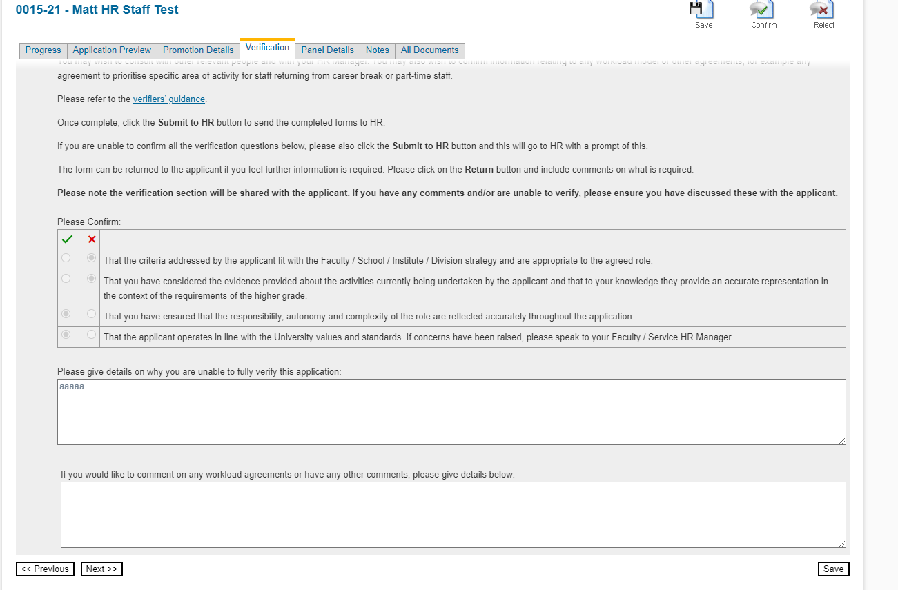

Verifying the Application
Please follow the instructions on the verification tab.
You are asked to tick all the verification statements to confirm these are all met. Please see below further explanation of this and what to do if you feel all the statements are not met.
You are also able to return the application to the applicant if you feel further information is required. This is described in option c below. In such case, the applicant can amend their application and it will be returned to you for verification once they re-submit.

Verified
Please tick to confirm each of the verification questions are met. You can provide any comments too should you so wish.
For grade 10 applications, please also provide details of your nominated referees, and confirm you are in support of the proposed title.
- Click the Submit to HR button.
Your completed verification, together with the completed application, will then be sent automatically through the system to the HR Promotions Team to arrange the promotion panel.

Unable to fully verify
If you are unable to confirm all the verification statements have been met, please include any comments on the reasons and ensure these have been discussed with the applicant. Please also speak to your Faculty HR Manager.
- Click the Submit to HR button.
The application will be processed and proceed to a promotion panel, but HR and the applicant will be notified that you have been unable to confirm all the verification statements. It is important therefore that you have discussed the reason for this with the applicant. Panel members will have sight of the verification section and of your comments.

Return the application to the applicant with suggestions / comments:
The application can be returned to the applicant if you feel further information is required. For example, if you feel the application would benefit from further context around the level of responsibility, autonomy and complexity of the role in relation to addressing the criteria.
If you wish to return the application, please ensure you have discussed the reasons for this with the applicant and note these in the comments section of the verification tab.
- Click the Return button.
The applicant then has the opportunity to revise their application. Once resubmitted it will be returned to you for verification.

Further information
General information on the promotion process can be found on the HR website and may be useful in providing context for the verification process.
If you have any questions or queries about the verifier role or the promotion process, please contact your Faculty HR Manager or HR promotions at promotions@leeds.ac.uk

Version/Amendment History: 001
Guidance Owner: Specialist Support - Human Resources Promotions
Guidance Author: Karen Garner, HR Strategic Programmes
Effective Date: (09/2022)

